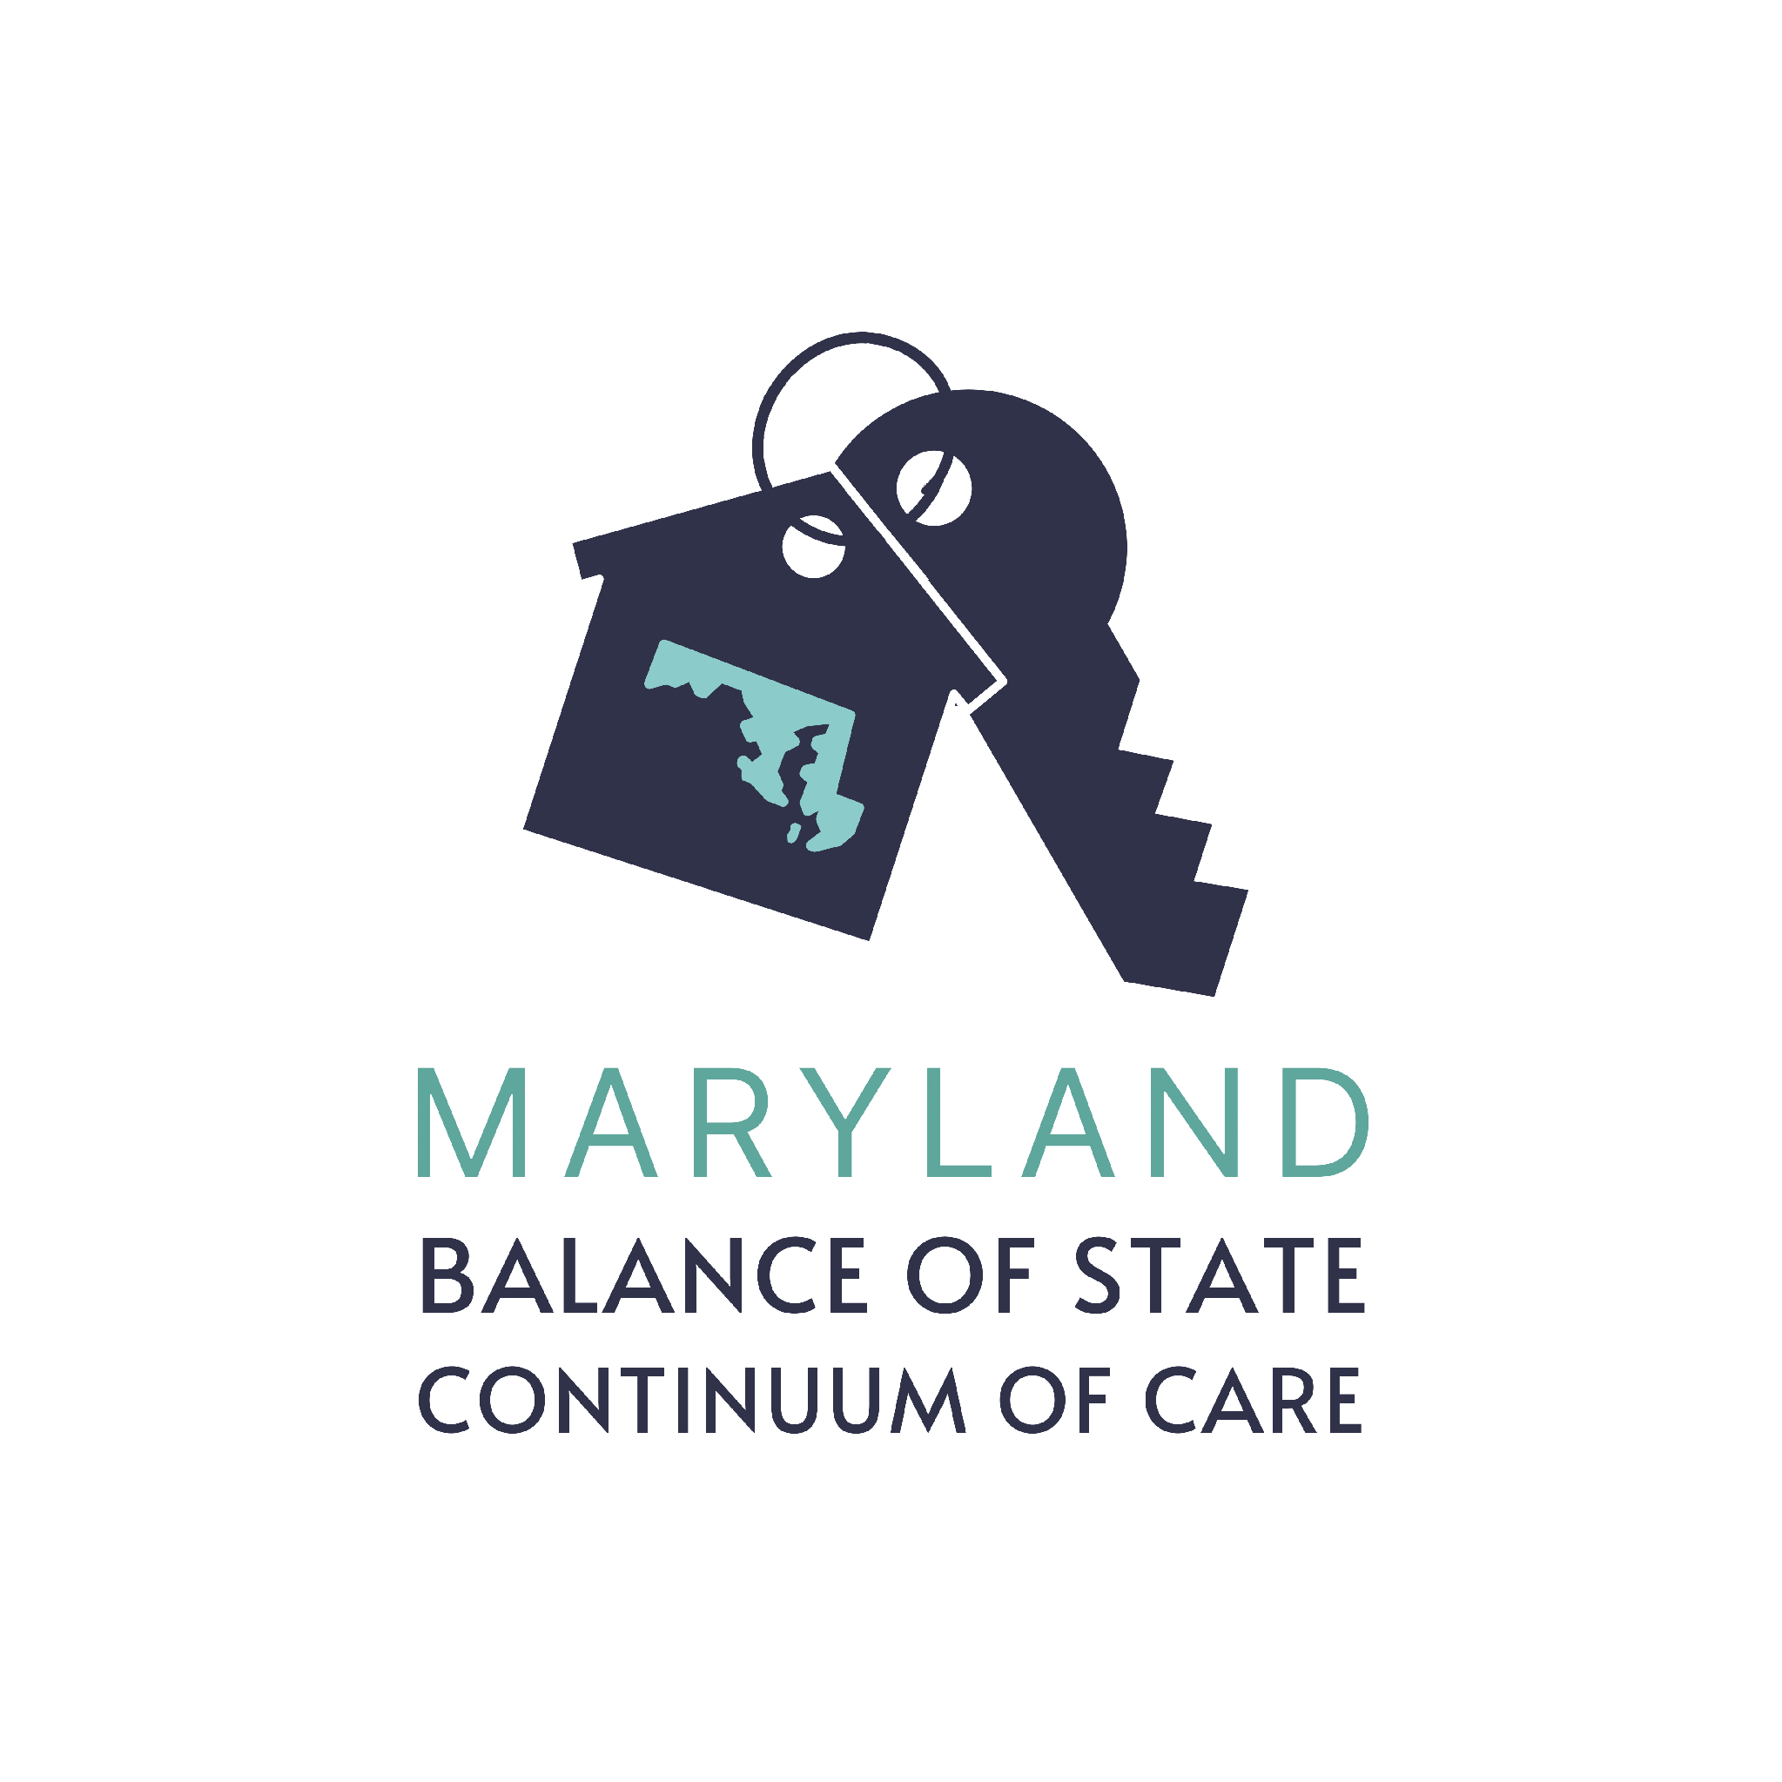
BoS CoC Competition Glossary

AC: Allegany County
ARD: The Annual Renewal Demand is the amount of money needed to fund 100% of the renewal projects in the next year
BoS: Balance of State Continuum of Care, MD-514
CC: Cecil County
CES: Coordinated Entry System - process developed to ensure that all people experiencing a housing crisis have fair and equal access and are quickly identified, assessed for, referred and connected to housing and assistance based on their strengths and needs
CoC: Continuum of Care - a regional or local planning body that coordinates housing and services funding for homeless families and individuals
CoC Bonus: CoC Bonus funding opportunity
CoC Program: Name of the HUD Grant
DV Bonus: Project that is dedicated to survivors of domestic violence, dating violence, sexual assault or stalking; bonus funding opportunity, now also eligibe for transitional housing projects
Expansion Projects: Renewal projects can apply for an expansion to expand existing eligible renewals that will increase the number of units in a project or allow the recipient to serve additional persons
FC: Frederick County
GC: Garrett County
HC: Harford County
HMIS: Homeless Management Information System
Joint TH-RRH: Project that includes two existing program components–transitional housing and permanent housing-rapid rehousing–in a single project to serve individuals and families experiencing homelessness
LHC: Local Homelessness Coalition, term used to describe the former individual CoCs
LS: Lower Shore
NOFO: Notice of Funding Opportunity
Performance Review Committee: Subcommittee of the CoC Board of Directors, makes funding and priority ranking determination submitted for Board approval
PSH: Permanent Supportive Housing
RFP: Request for Proposals, all project applicants were required to respond to the CoC RFP
RRH: Rapid Re-housing
Reallocation: CoC shifts funds in whole or part from existing eligible renewal projects to create one or more new projects without decreasing the CoC’s ARD
Renewal Grants: Projects currently funded and applying for renewed funding this year
Scorecard: Renewing project performance is measured via the Renewal Project Scorecard which evaluated project performance, HMIS, and general grant management
SM: Southern Maryland (Calvert, Charles & St. Mary’s Counties)
SSO: Supportive Services Only
TH: Transitional Housing
Tier 1: Equal to 60% of the CoC ARD, projects that fall in Tier 1 are conditionally selected for funding by HUD
Tier 2: The remaining funding beyond Tier 1, awarded by priority order
Transition Grant: Grant to convert an existing CoC project from one component type to another
WC: Washington County

